Session 5

1.Create a table called Restaurants with columns: id, name, cuisine, rating, and city. Insert at least 5 sample records representing real or fictional restaurants you might find on Zomato.

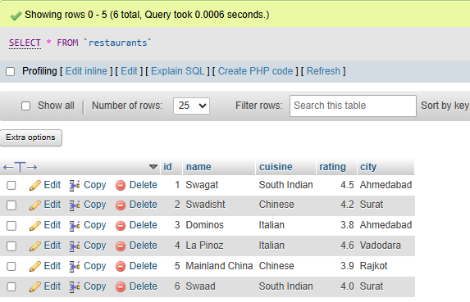

2. Write a SQL query to find all restaurants in the Restaurants table that have a rating greater than 4.0 and are located in either 'Ahmedabad' or 'Surat'.
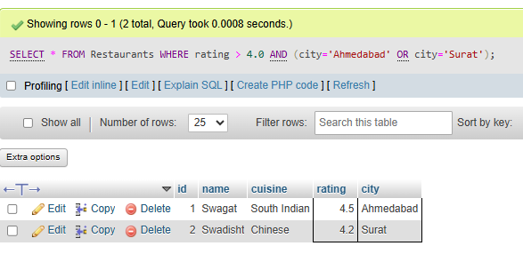
3. Using the LIKE operator, write a query to select all restaurants whose names start with 'Swa' (for example, 'Swagat', 'Swadisht') from the Restaurants table.<br><br><em><strong>Hint:</strong> Use LIKE 'Swa%'.</em>

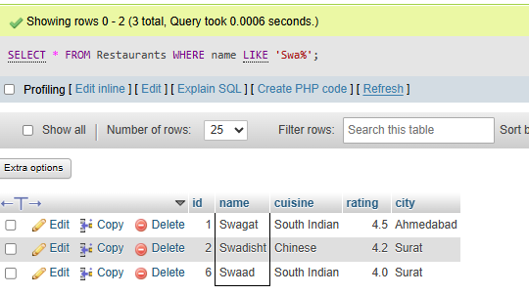
4. Write a SQL query using the BETWEEN keyword to find all restaurants in the Restaurants table with a rating between 3.5 and 4.5 (inclusive).
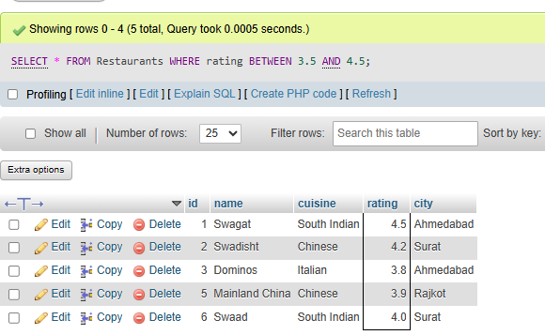
5. Write a query to find all restaurants whose cuisine is either 'Chinese', 'Italian', or 'South Indian' using the IN operator.

